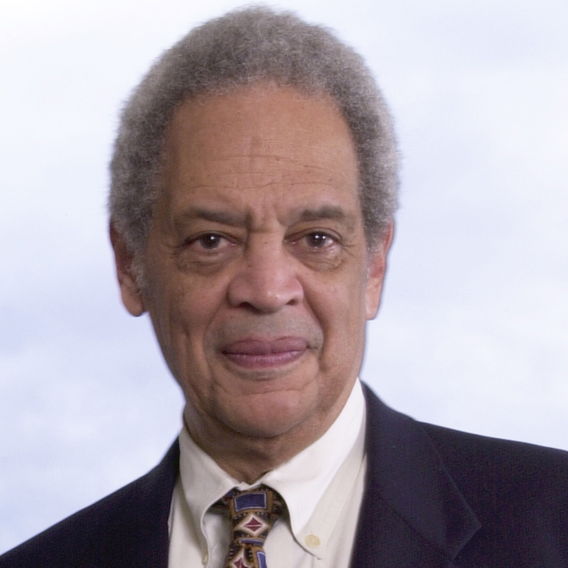
Roger Wilkins
Pulitzer Prize-Winning Journalist and Civil Rights Advocate
Roger Wilkins was born in 1932 in Kansas City, Missouri. His father, a business manager with a prominent black paper, The Kansas City Call, died when Wilkins was a child and the family moved to New York and then to Michigan, where Wilkins spent most of his formative years.
He attended the University of Michigan, receiving his BA in 1953 and his JD in 1956, and interned with Thurgood Marshall at the NAACP’s Legal Defense Fund. Following graduation, he worked in several capacities as an advocate for justice. (His interest in legal issues and equality stems partially from his family’s background. His uncle, Roy Wilkins was executive secretary of the NAACP from 1955 to 1977). He began his career as a caseworker in the Ohio Welfare Department and then went to work for the US government.
During his seven-year government career, he worked for such agencies as the US Agency for International Development, the Department of Commerce, and the Department of Justice. He eventually rose to serve as the assistant attorney general of the United States under President Lyndon B. Johnson from 1966-1969.
Leaving government at the end of the Johnson administration, he worked briefly for the Ford Foundation before he embarked on what was to become his second major – and equally successful – career as an editor and commentator for newspaper and radio in New York and Washington. He joined the editorial staff of the Washington Post, where he took on the role for which he is best known – exposing Watergate in the 1970’s – a feat that earned him for the Pulitzer Prize along with Bob Woodward, Carl Bernstein, and Hal Herblock.
After a short time as a member of the editorial page staff at the Washington Post, he returned to New York City for five years (1974-1979), where he was a member of the editorial board of the New York Times.

Never quite able to resist the lure of DC’s dual power and charm, he returned in 1980 to assume the role of associate editor of the now-defunct Washington Star. From there, he quickly moved to CBS News, where he became a network radio commentator. In 1990, he became a network radio commentator for National Public Radio (NPR) – a role he continues to this day.
In addition to his work for NPR, he is the author of two books: A Man’s Life: An Autobiography and Jefferson’s Pillow: The Founding Fathers and the Dilemma of Black Patriotism. He is also the publisher of the NAACP’s journal, Crisis, and the co-editor of Quiet Riots: Race and Poverty in the United States. He has also written more than 60 books reviews and op-ed pieces for major American newspapers, published articles in dozens of magazines, and conceived, written, and narrated two Frontline documentaries. He’s also a former Clarence J. Robinson Professor of History and American Culture at George Mason University.
In addition to his Pulitzer, he holds several honorary degrees, and has served on many boards, including those of the NAACP and the African-American Institute. In 1990, he was the national coordinator of Nelson Mandela’s visit to the United States.

